

**University of engineering & technology Peshawar**

**Circuit & system-ll lab**

**Lab report no#04**

**Fall 2020**

**Submitted by: Ashfaq Ahmad**

**Section: B**

**Reg No: 19PWCSE1795**

**Semester: 3rd**

**“On my honor, as a student of University of Engineering and Technology Peshawar, I have neither given nor received unauthorized assistance on this academic work”**

Student signature: ____________________

**Submitted to:**

**Eng: Faiz ullah**

**Department Of Computer System Engineering**

In this lab we will analyze the RLC-circuit by using proteus. In case of series RLC circuit the voltage is divided so we will find voltage across each component theoretically and experimentally and then finally we will find %deviation. Of particular importance is the phase of the various components and how Kirchhoff’s Voltage Law is extended for AC circuits. Both time domain and phasor plots of the voltages are generated.

**Theory Overview**

Each element has a unique phase response: for resistors, the voltage is always in phase with the current, for capacitors the voltage always lags the current by 90 degrees, and for inductors the voltage always leads the current by 90 degrees. Consequently, a series combination of R, L, and C components will yield complex impedance with a phase angle between +90 and -90 degrees. Due to the phase response, Kirchhoff’s Voltage Law must be computed using vector (phasor) sums rather than simply relying on the magnitudes. Indeed, all computations of this nature, such as a voltage divider, must be computed using vectors.

**Equipment:**

1. AC Function Generator
2. Oscilloscope

**Components:**

1. 10 nF actual:_________
2. 10 mH actual:_________
3. 1 kΩ actual:_________

**Circuit diagram:**

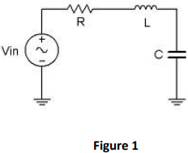

**Procedure:**

* Using Figure 1 with Vin=2Vp-p sine at 10 kHz, R=1kΩ, L=10mH and C=10nF, determine the theoretical inductive and capacitive reactance and circuit impedance, and record the results in Table 1 (the experimental portion of this table will be filled out in step 4). Using the voltage divider rule, compute the resistor, inductor and capacitor voltages and record them in Table 2.
* Build the circuit of Figure 1 using R=1kΩ, L=10mH and C=10nF. Set the generator to a 10 kHz sine wave and 2 Vp-p. Using oscilloscope measure the signals. Unfortunately, it is impossible to see the voltages of all the three components simultaneously using only two probes of the oscilloscope. To obtain the proper readings, place one probe on the function generator to see the input signal and the second probe across the last element. This step is repeated three times. The first time the components are so arranged that capacitor is the last component, the second time inductor is connected as the last component and finally resistor is made the last component. The peak-to peak voltages and phase angles of each one of the three components, relative to the source are thus determined in turn. Thus Vs, VC, VL and VR are measured. Record in Table 2.
* Compute the deviations between the theoretical and experimental values of Table 2 and record the results in the final columns of this table.
* Based on the experimental values, determine the experimental Z, XL and XC values via Ohm’s Law (i=VR/R, XL=VL/i, XC=VC/i, Z=Vin/i) and record back in Table 1 along with the deviations.
* Create a phasor plot showing Vin, VL, VC, and VR.
* Repeat the experiment for 1nF capacitor, 1mH inductor and 1kΩ resistor.

**Phasor diagram:**

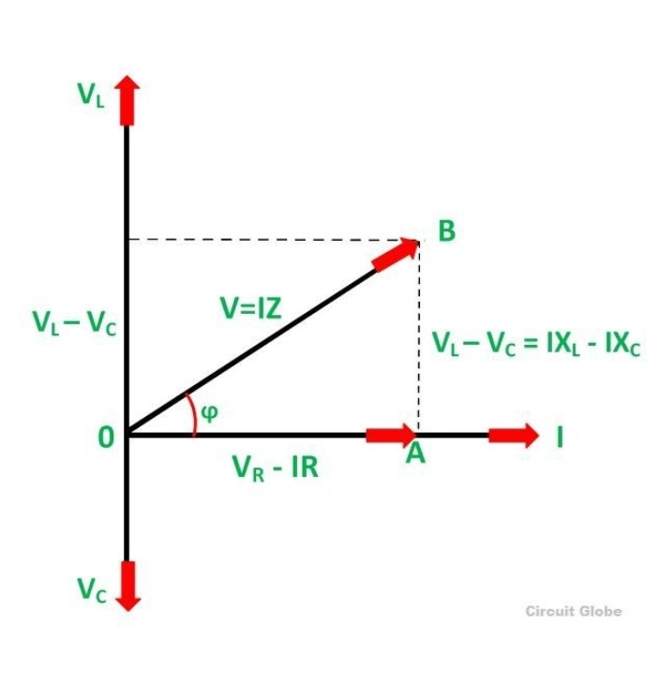

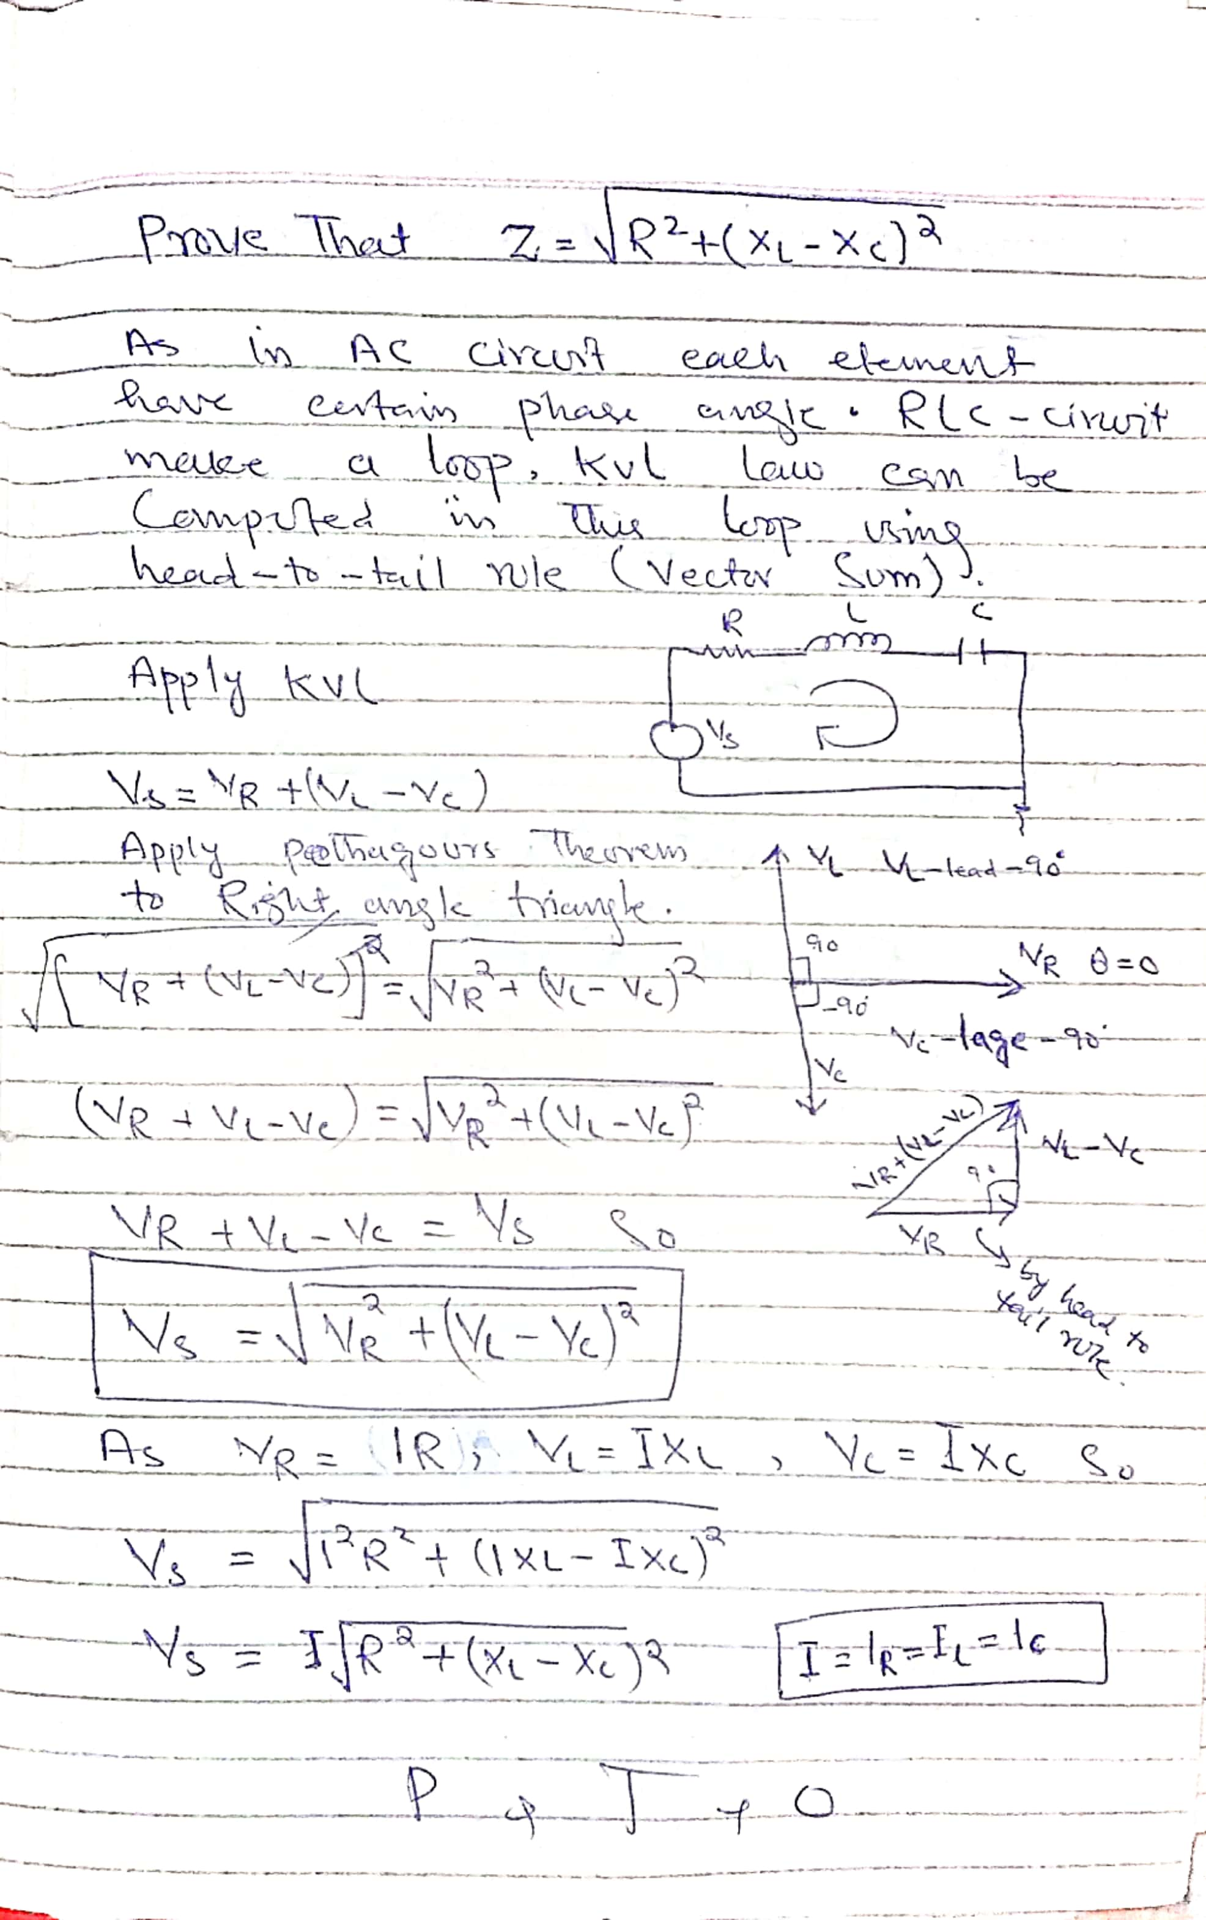 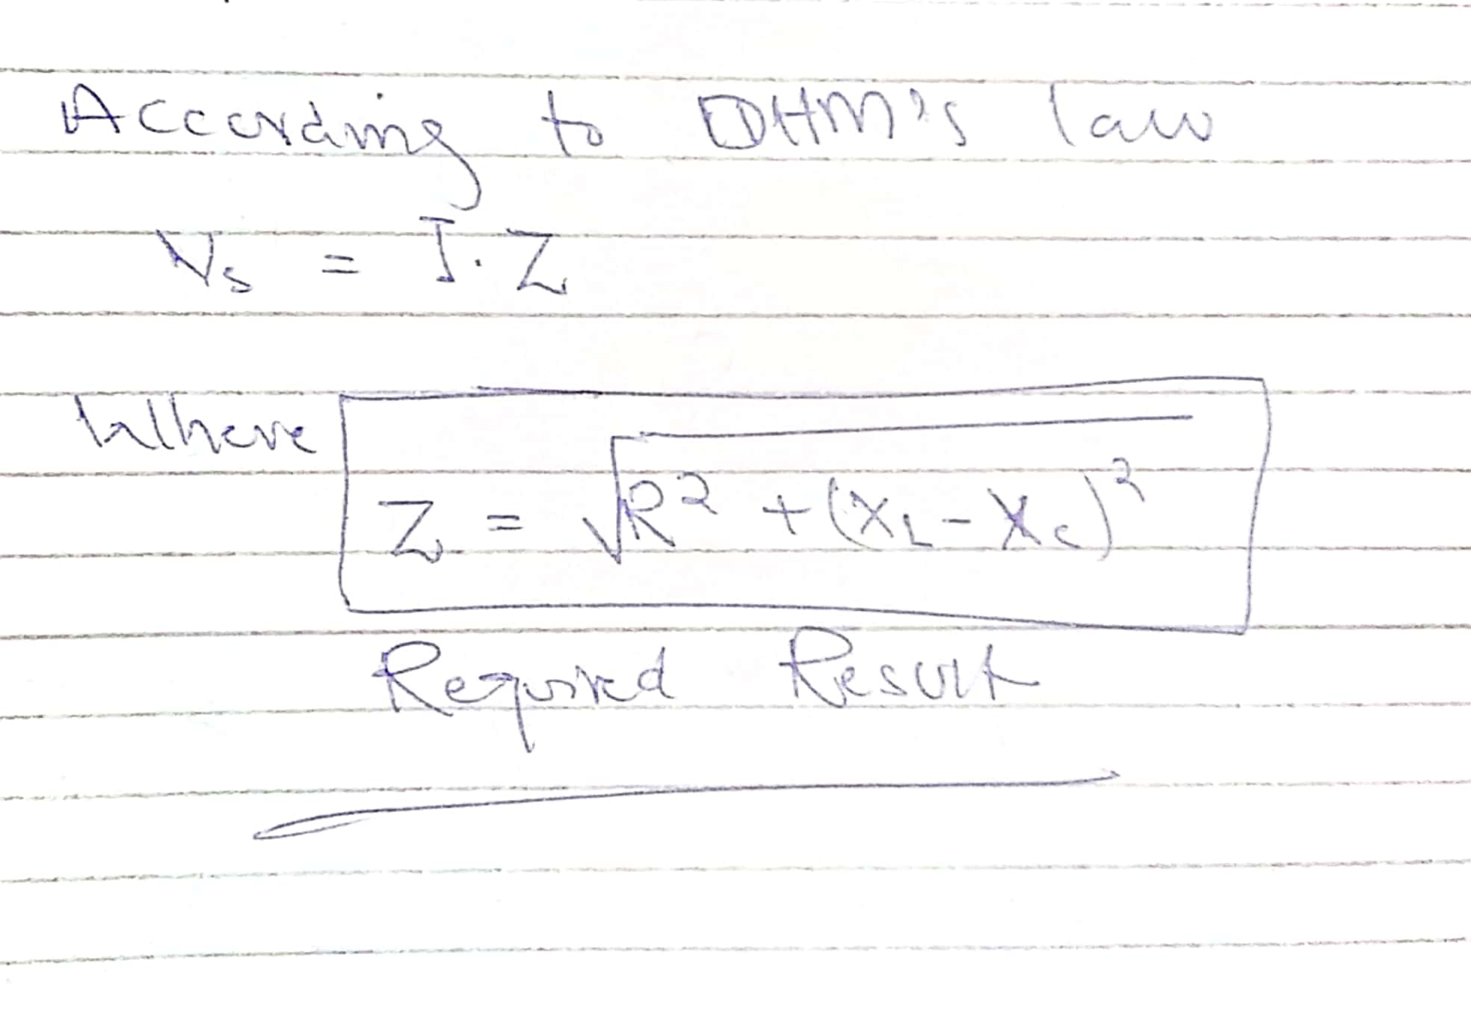 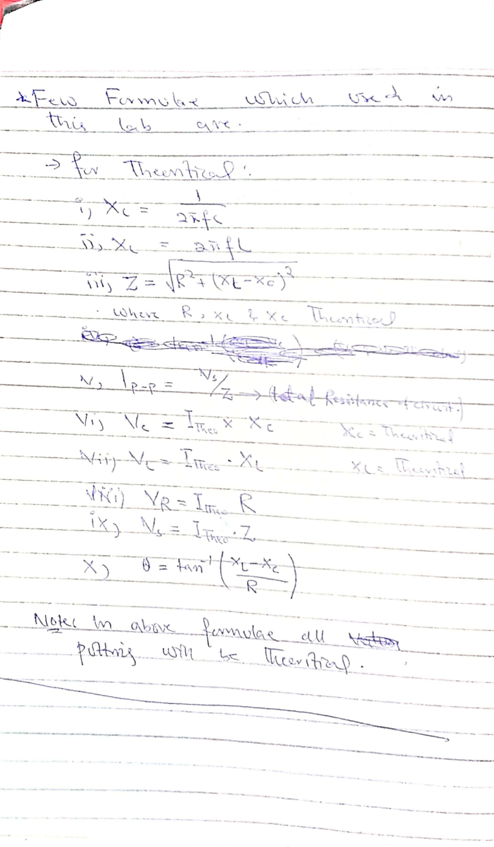 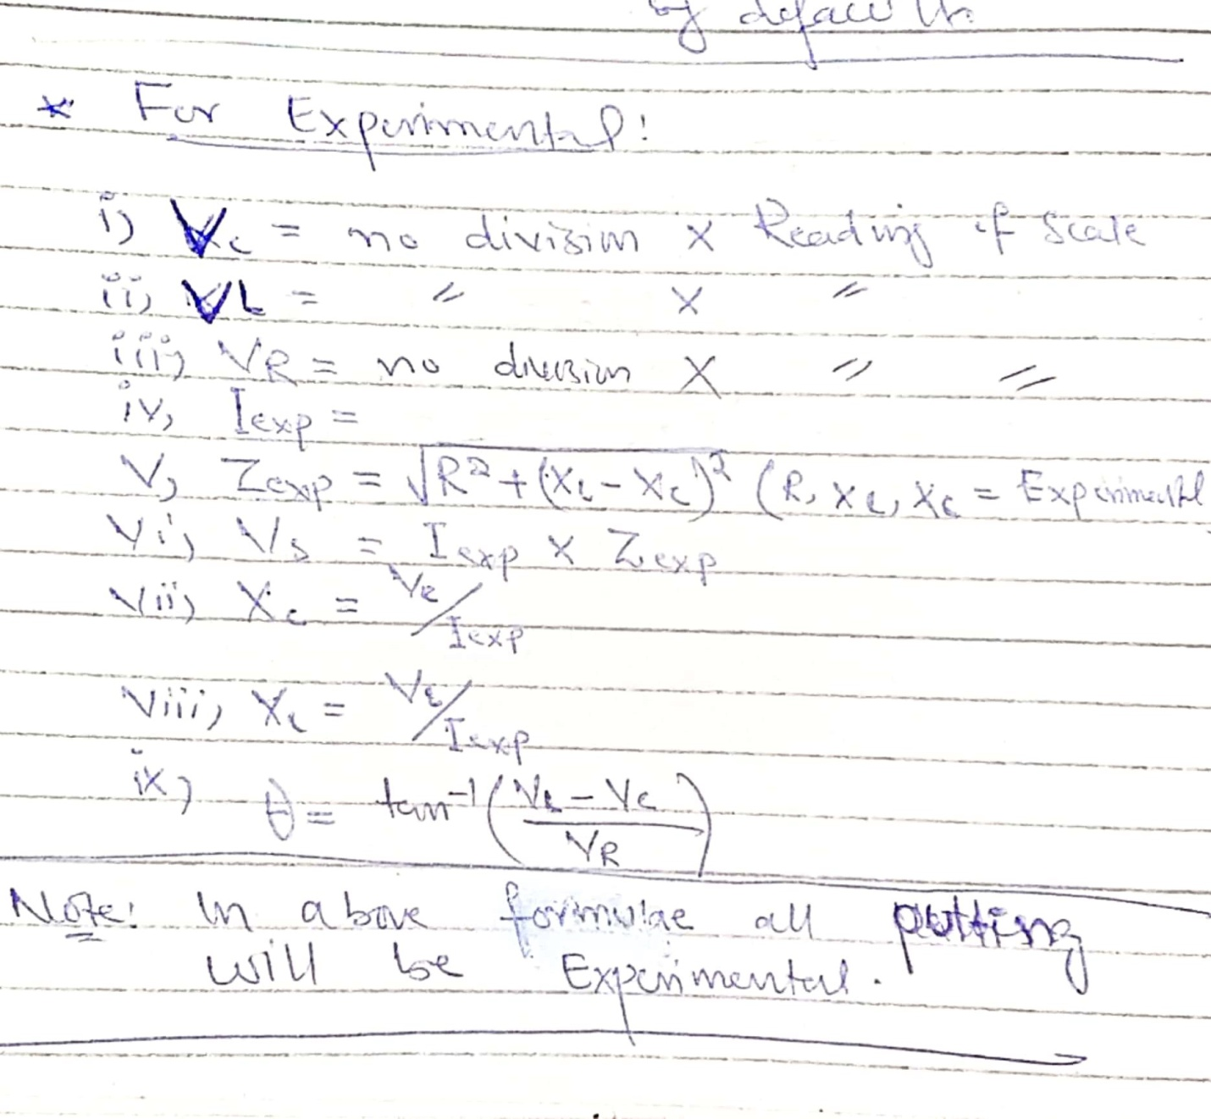

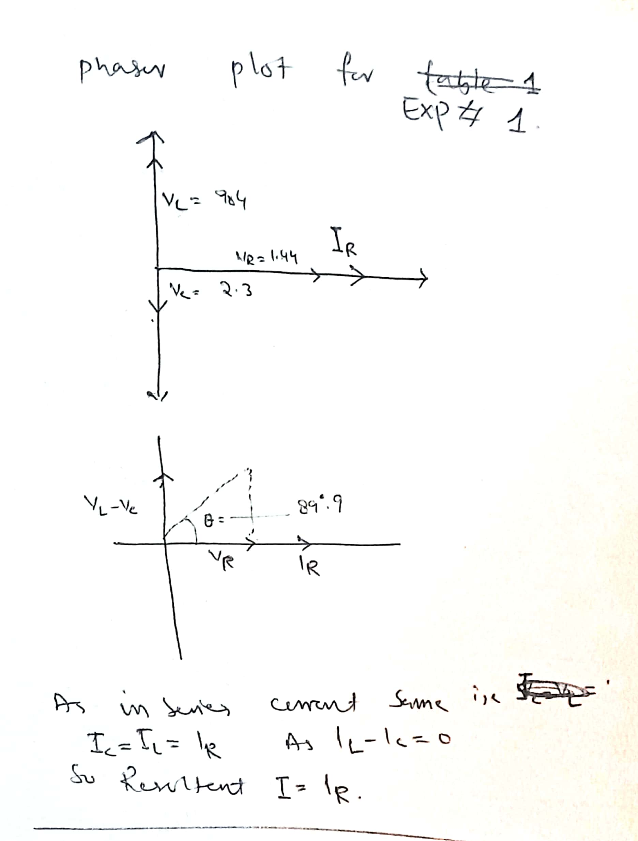

**Data Tables:**

**For C=10nF, R=1k, L=10mH, f=10k.**

**Note: the value of R is same in both exp and theoretical case.**

|  |  |  |
| --- | --- | --- |
|  | theoretical | experimental |
| Ip-p | **1.44mA** | **1.47mA** |

Table 1

|  |  |  |  |
| --- | --- | --- | --- |
|  | Theoretical | Experimental | %Deviation |
| XC | 1591.5 | 1632.65 | -2.58 |
| XL | 628.3 | 622 | 1.00 |
| Z | 1388.4 | 1421 | -2.34 |
| Ɵ | -43.83 | -45.28 | -3.30 |
| Table 2 | | | |

|  |  |  |  |
| --- | --- | --- | --- |
|  | theoretical value | Exp value | %Deviation |
| VC | **2.3** | **2.4** | **-4.3** |
| VL | **904.8** | **914.33** | **-1.05** |
| VR | **1.44** | **1.5** | **-4.16** |
| VS | **1.99** | **2.08** | **-4.5** |
| Ɵ | **89.9** | **89.93** | **0.03** |

Table 3

**Data tables:**

**For C=1nF, R=1k, L=1mH, f=5k.**

**Note:** In experiment 2 I took f=5k because at f=10k my laptop do not support proteus.

**Note: the value of R is same in both exp and theoretical case**

|  |  |  |
| --- | --- | --- |
|  | theoretical | experimental |
| Ip-p | **12.5uA** | **62.4uA** |

Table 1

|  |  |  |  |
| --- | --- | --- | --- |
|  | Theoretical | Experimental | %Deviation |
| XC | 31847 | 32258 | -1.29 |
| XL | 31.4 | 32.25 | -2.7 |
| Z | 31831 | 32241 | -1.28 |
| Ɵ | -88.19 | -88.22 | -0.34 |
| Table 2 | | | |
|  | | | |

|  |  |  |  |
| --- | --- | --- | --- |
|  | Theoretical value | Exp value | %Deviation |
| VC | **1.97** | **2** | **-1.52** |
| VL | **0.0019** | **0.002** | **-5.2** |
| VR | **0.062** | **0.046** | **20.80** |
| VS | **1.97** | **1.99** | **-1.01** |
| Ɵ | **-88.19** | **-88.68** | **-0.55** |

Table 3

**Questions**

1. What is the phase relationship between R, L, and C components in a series AC circuit?

**Answer:**

The instantaneous voltage across a pure resistor, VR is “in-phase” with current the instantaneous voltage across a pure inductor, VL “leads” the current by 90o .the instantaneous voltage across a pure capacitor, VC “lags” the current by 90oTherefore, VL and VC are 180o “out-of-phase” and in opposition to each other. For the series RLC circuit above, this can be shown as:

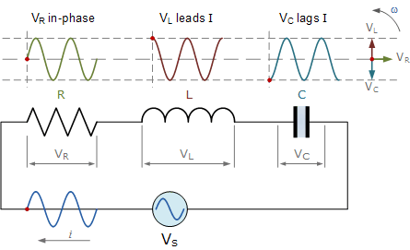

1. Based on measurements, does Kirchhoff’s Voltage Law apply to the tested circuits?

**Answer:** yes we can apply kvl law to the tested circuit; it will give result with some error.

1. In general, how would the phasor diagram of Figure 1 change if the frequency was raised?

**Answer:** As we know that there is direct relationship between inductive reactance and frequency and inversely relationship between frequency and capacitive reactance, so if the frequency increase the voltage phasor vector of inductor increase while the voltage phasor vector of capacitor decrease. As there is no relationship between frequency and resistance so resistance phase vector will remain constant.

1. In general, how would the phasor diagram of Figure 1 change if the frequency was lowered?

**Answer:** here process will be reverse, so if the frequency decrease the voltage phasor vector of inductor decrease while the voltage phasor vector of capacitor increase. As there is no relationship between frequency and resistance so resistance phase vector will remain constant.

THE END